**Back-to-School 2025: Tools to Help Keep Kids Safer Online**

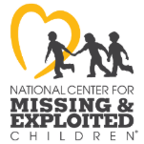

As kids head back to school, online safety matters more than ever. The National Center for Missing & Exploited Children (NCMEC) provides vital resources to families, educators, and professionals with the tools they need to protect children in an increasingly digital world.

As students settle into new routines, they’re also spending more time on devices; for homework, socializing, gaming, and more. This increased screen time brings new and evolving risks, including some threats that didn’t even exist a few years ago.

We encourage you to share these resources with your community. Together, we can empower children to make safer choices and create a more secure digital environment.

We’ve also included sample social media posts on the latest online safety topics; ready for you to share with your audience to help spread awareness.

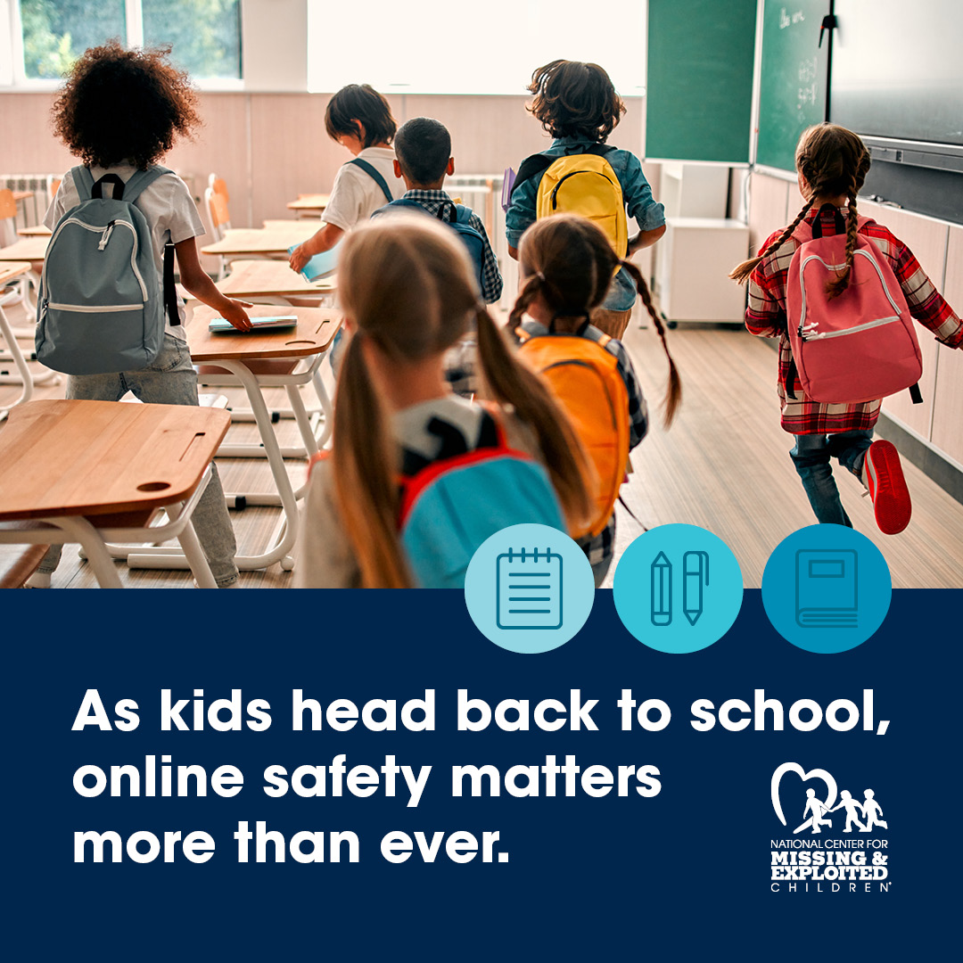

As kids head back to school, online safety matters more than ever. We’re proud to support @NCMEC, who are on the frontlines providing families, educators, and professionals with tools to help protect children in today’s digital world. Learn more: <https://www.missingkids.org/blog/2025/back-to-school-in-the-age-of-ai-new-tools-for-kids>

**About NetSmartz**

NetSmartz is NCMEC’s online safety education program, offering age-appropriate videos and activities to help children stay safer online. The goal is to build awareness of potential risks and empower kids to make safer choices both on- and offline. <https://www.youtube.com/watch?v=JWas95dE3Xk>

**Option 1**  
New @NetSmartz episode!  
Clicky & Nettie discover someone using AI to create fake images in Falsizone. With Gig’s help, they’re on a mission to stop it—and show kids what to do if they see something concerning online.  
Watch here: <https://www.youtube.com/watch?v=JWas95dE3Xk>

**Option 2**  
AI fakes? Not in Falsizone!  
In the latest @NetSmartz adventure, Clicky, Nettie & Gig team up to stop the misuse of AI and remind kids: if something feels wrong online, it’s never their fault—speak up!  
Watch the episode: <https://www.youtube.com/watch?v=JWas95dE3Xk>

**All of our NetSmartz videos can be found here:** [**https://www.youtube.com/@NetSmartzWorkshop**](https://www.youtube.com/@NetSmartzWorkshop)

**Generative Artificial Intelligence**

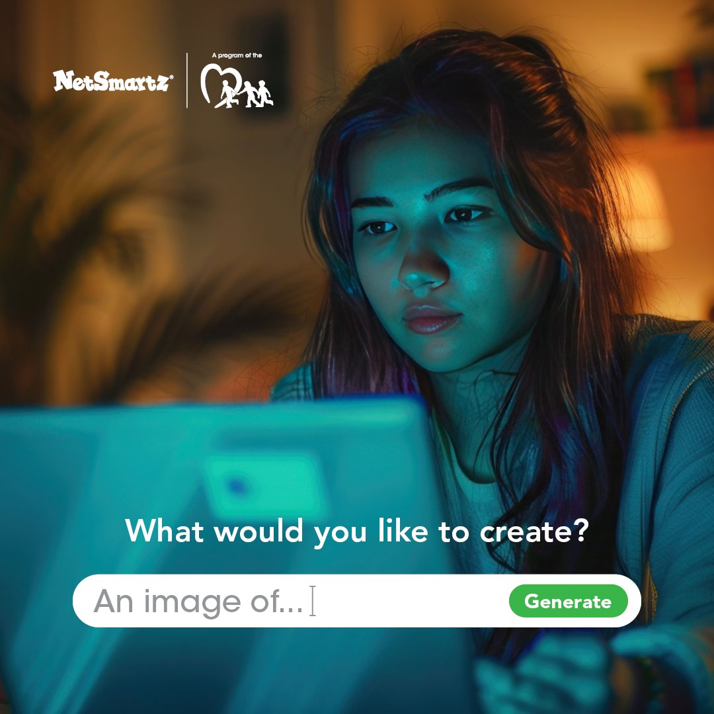

**Parents & Caregivers:** AI can be an incredible tool for learning and creativity—but like any tool, it can be misused. Learn how to talk with kids about the risks and help them use AI safely and responsibly: <https://ncmec.org/NetSmartz/GAI>

**Sextortion**

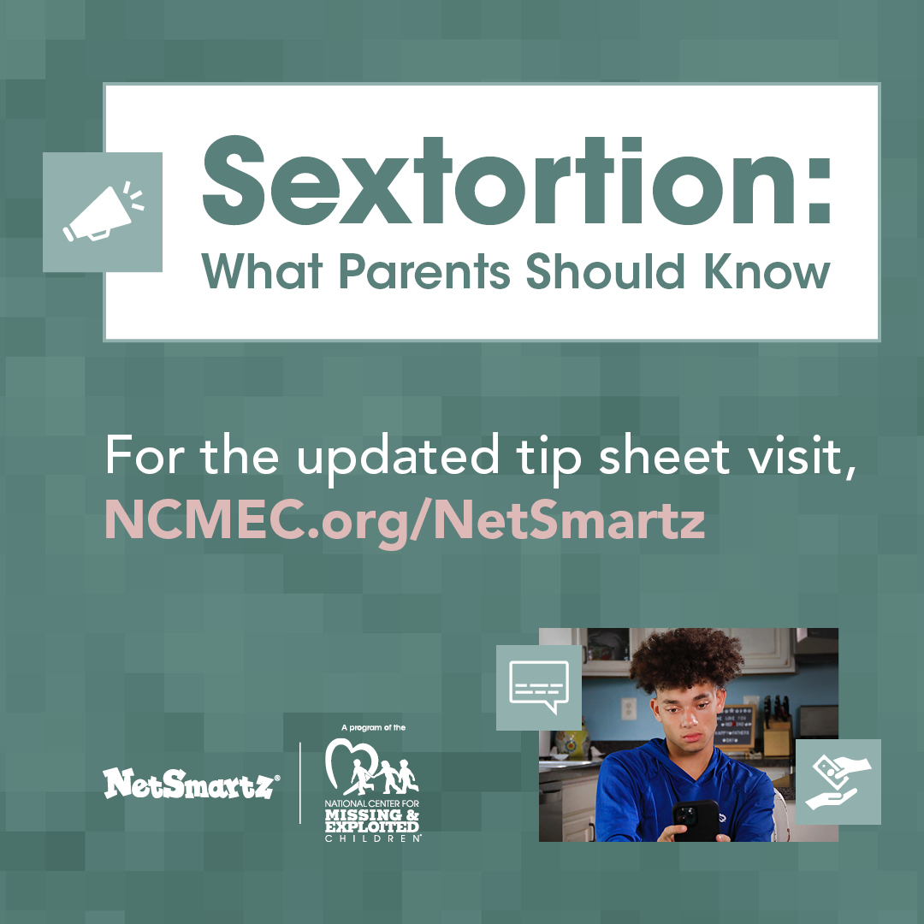

Sextortion cases are on the rise—but open, honest conversations can help protect kids.  
Check out @NetSmartz’s tip sheet for guidance on talking with your child about online risks and safety: <http://ncmec.org/netsmartz>

Together, we can empower kids to #StaySafeOnline.

**NO ESCAPE ROOM** is an interactive film designed to help teens understand the real-life dangers of sextortion. It puts viewers in the shoes of a teen being targeted, showing just how quickly things can spiral and how hard it can be to ask for help.

This isn’t just a film; it’s a powerful educational tool to spark conversations and protect kids from online exploitation. Watch now: <https://noescaperoom.org/>

**Classroom-Ready Online Safety Lessons (K–12)**

Educators, empower your students to be safer online with our free collection of teaching materials for families and students in grades K–12. Topics include cyberbullying, online enticement, sextortion, gaming, and sexting. Materials are available in English and Spanish and include ready-to-use Google Slides: <https://www.missingkids.org/NetSmartz/Resources>

[**You can download our visuals here.**](https://www.dropbox.com/scl/fo/f3vcjyefaio2vz57s6e5s/AP2SxlWmU1M_wbKuzYrdxPM?rlkey=yyd8l14nuv94445pvmpqz58u9&st=avb5qwoj&dl=0)



Stay informed and up to date on the latest trends. Sign up for the NetSmartz newsletter and learn how you can help kids stay safer online: <https://go.missingkids.org/l/808593/2020-02-24/7gz7>