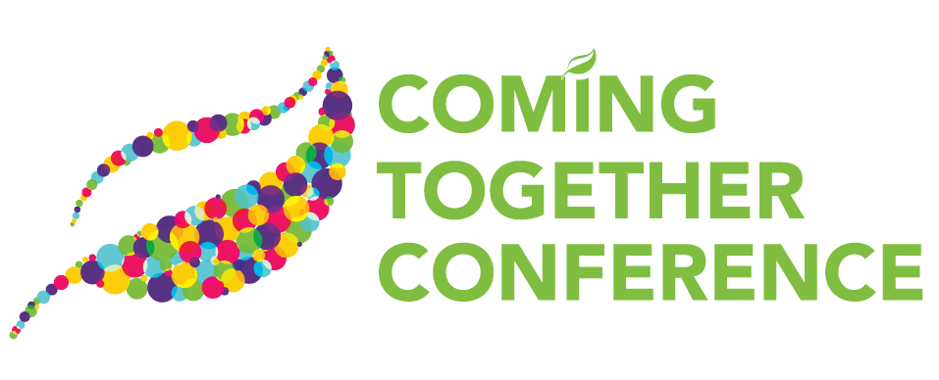

**2024 CONFERENCE EVALUATION**

As a result of the **keynote** sessions at this conference:

Strongly Somewhat Somewhat Strongly Did Not

Agree Agree Neutral Disagree Disagree Attend

1. *Dare them to Dream: Building Recovery Capital Step by Step*I am able to identify ways to incorporate recovery capital ⭘ ⭘ ⭘ ⭘ ⭘ ⭘  
   per each phase of treatment.
2. *Recovery Capital – The Importance of Measurement*  
   I understand the logic and rationale of recovery science. ⭘ ⭘ ⭘ ⭘ ⭘ ⭘

As a result of the **breakout** sessions at this conference:

Strongly Somewhat Somewhat Strongly Did Not

Agree Agree Neutral Disagree Disagree Attend

1. *Implicit Bias Related to Addiction (Tuesday)* ⭘ ⭘ ⭘ ⭘ ⭘ ⭘

I am able to identify and understand implicit bias.

1. *Personal Journey – Cultivating Recovery Capital (Tuesday)* ⭘ ⭘ ⭘ ⭘ ⭘ ⭘

I have gained a better understanding of the concept of

Recovery Capital, how it was created and why it can have

an impact in my field.

1. *Closing the Treatment Gap: Integrating Medications for* ⭘ ⭘ ⭘ ⭘ ⭘ ⭘

*Addiction Treatment and Harm Reduction into Emergency Care*

I am able to explain why treating opioid disorder with   
medications is safe and indicated.

1. *Helping Our Underserved Populations* ⭘ ⭘ ⭘ ⭘ ⭘ ⭘

I learned strategies to implementing the six pillars of   
harm reduction.

1. *Opioid Settlement Funds Deployment with Southwest* ⭘ ⭘ ⭘ ⭘ ⭘ ⭘  
   *Michigan Behavioral Health*I can describe the sources and permitted uses of state,  
    county and municipal opioid settlement funds.
2. *Substance Use Youth Panel Discussion* ⭘ ⭘ ⭘ ⭘ ⭘ ⭘

I am able to identify early signs of substance use or risky   
behaviors among youth, allowing for timely intervention   
and support.

As a result of the **breakout** sessions at this conference (cont.): Strongly Somewhat Somewhat Strongly Did Not

Agree Agree Neutral Disagree Disagree Attend

1. *Gun Lake Tribe Health and Human Services: Mental Health* ⭘ ⭘ ⭘ ⭘ ⭘ ⭘  
   *Services for American Indians/ Alaska Natives (AI/AN)*

I am able to identify cultural consideration when working   
with American Indians/Alaska Natives.

1. *Cannabinoid and Emerging Substance Trends in Oral Fluid* ⭘ ⭘ ⭘ ⭘ ⭘ ⭘  
   I can describe the diversity of novel drugs and their health   
   implications.
2. *Recognizing and Addressing Neurodiversity in Your Substance* ⭘ ⭘ ⭘ ⭘ ⭘ ⭘  
   *Use Disorder Clients*  
   I can recognize the hyper-sensory experiences of neurodiverse  
   clients.
3. *Cultivating Cultural Competency: Uncovering Biases and* ⭘ ⭘ ⭘ ⭘ ⭘ ⭘ *Building Inclusive Communities*I am able to identify the core components of cultural   
   competency, including awareness, knowledge and skills.
4. *New and Upcoming Sober Housing* ⭘ ⭘ ⭘ ⭘ ⭘ ⭘

I learned about the continuum of housing options in   
Kalamazoo County for those with an SUD.

1. *Management of Substance Use Disorders in the Perinatal Period* ⭘ ⭘ ⭘ ⭘ ⭘ ⭘

I can give examples of the safety of pharmacological   
management of substance use disorders in the perinatal period.

1. *Psychedelics and Cyberdelics Role in Treating SUD and* ⭘ ⭘ ⭘ ⭘ ⭘ ⭘ *Psychiatric Disorders*

I can list the approved substances and indications for   
psychedelic-assisted therapy.

1. *The Impact of Parental Substance Use on Infant and Early* ⭘ ⭘ ⭘ ⭘ ⭘ ⭘ *Childhood Mental Health*

I am able to identify ways in which parent/caregiver substance   
misuse can lead to poor outcomes for IECMH.

**The following presenters provided dynamic and informative sessions:**

Strongly Somewhat Somewhat Strongly Did Not

Agree Agree Neutral Disagree Disagree Attend

Dominick Gladstone: *Implicit Bias Related to Addiction (Tuesday)* ⭘ ⭘ ⭘ ⭘ ⭘ ⭘

David Best: *Personal Journey – Cultivating Recovery Capital (Tuesday)* ⭘ ⭘ ⭘ ⭘ ⭘ ⭘

Carolyn Hardin: *Morning Keynote: Dare them to Dream:* ⭘ ⭘ ⭘ ⭘ ⭘ ⭘

*Building Recovery Capital Step by Step*

Maureen McGlinchey Ford: *Closing the Treatment Gap* ⭘ ⭘ ⭘ ⭘ ⭘ ⭘

Andre Johnson: *Helping Our Underserved Populations* ⭘ ⭘ ⭘ ⭘ ⭘ ⭘

Bradley Casemore, Amy Dolinky and Jen Strebs: *Opioid Settlement* ⭘ ⭘ ⭘ ⭘ ⭘ ⭘  
*Funds Deployment*

Helena Cole, Emma Brow and Victoria Orbe: *Substance Use Youth* ⭘ ⭘ ⭘ ⭘ ⭘ ⭘  
*Panel Discussion*

James “Bud” Day and Rebecca Werner: *Gun Lake Tribe Health* ⭘ ⭘ ⭘ ⭘ ⭘ ⭘  
*and Human Services*

Jerome Pete Reed: *Cannabinoid and Emerging Substance Trends* ⭘ ⭘ ⭘ ⭘ ⭘ ⭘  
*in Oral Fluid*

Judith Lipson: *Recognizing and Addressing Neurodiversity in* ⭘ ⭘ ⭘ ⭘ ⭘ ⭘  
*Your SUD Clients*

David Best: *Afternoon Keynote: Recovery Capital – The*⭘ ⭘ ⭘ ⭘ ⭘ ⭘  
*Importance of Measurement*

Kenlana Ferguson: *Cultivating Cultural Competency* ⭘ ⭘ ⭘ ⭘ ⭘ ⭘

Chris Pompey, Pamela Coffey and Matt Hollander: *New and* ⭘ ⭘ ⭘ ⭘ ⭘ ⭘  
*Upcoming Sober Housing*

Madhavi Latha Nagalla: *Management of Substance Use Disorders* ⭘ ⭘ ⭘ ⭘ ⭘ ⭘  
*in the Perinatal Period*

Mark Goetting: *Psychedelics and Cyberdelics Role in Treating SUD* ⭘ ⭘ ⭘ ⭘ ⭘ ⭘  
*and Psychiatric Disorders*

Amber R. Walker: *The Impact of Parental Substance Use on Infant* ⭘ ⭘ ⭘ ⭘ ⭘ ⭘  
*and Early Childhood Mental Health*

**Overall Evaluation of the Conference**

Strongly Somewhat Somewhat Strongly

Agree Agree Neutral Disagree Disagree

1. The selection of topics was excellent. ⭘ ⭘ ⭘ ⭘ ⭘
2. The conference met my expectations. ⭘ ⭘ ⭘ ⭘ ⭘
3. The conference was well organized. ⭘ ⭘ ⭘ ⭘ ⭘
4. Each presentation was objective, balanced, and free of ⭘ ⭘ ⭘ ⭘ ⭘

commercialization

1. What was the MOST useful presentation at this conference? Why?
2. What was the LEAST useful presentation at this conference? Why?
3. How did this conference compare to other similar conferences you have attended?
4. Suggested topics for future conferences:
5. Additional Comments: